
来华留学申请表
Application Form for Foreign Students

姓名 Name  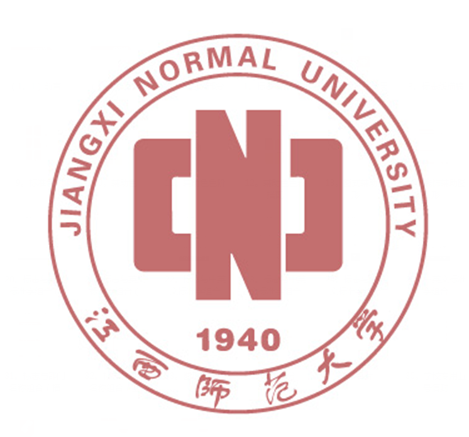 | 外文  In Foreign Language |  |  |  |  |  | 照片  Recent Portrait  4cm *3cm
 | 中文  In Chinese |  |  | 性别 □ 男 Male  Sex □ 女Female |  |  | 照片  Recent Portrait  4cm *3cm
国籍 Nationality |  | 护照号码 Passport No. |  | 婚否 □未婚Single  Marital □已婚Married |  |  | 照片  Recent Portrait  4cm *3cm
出 生 日 期 年 月 日 年龄  Date of Birth Year Month Day Age |  |  |  |  | 出生地  Place of Birth
通讯地址Mailing Address / 电话、传真、电子邮件地址 Tel &Fax& E-mail Address
___________________________________________________________________________________________________

最后学历 Highest Academic Degree Obtained |  |  | 职业 Occupation |  |  | 宗教信仰 Religion
工作或学习单位 Where are you currently studying or working?

教育背景 Educational Background( from Senior Middle School)

Name of School Study Period Diploma or Degree awarded

1_______________________________ ____YY___MM until____YY___MM ___________________

2_______________________________ ____YY___MM until____YY___MM ___________________

何地学习过多长时间汉语 Where and how long have you studied Chinese ?

现有汉语水平Present level of Chinese
□入门Beginner □初级Primary □中级Intermediate □高级Advanced

来华留学类别 Categories of Foreign Students

□语言生 □普通进修生 □博士研究生
Language student General Scholar Doctor’s program
□本科生 □硕士研究生 □高级进修生
Undergraduate Master’s program Advanced Scholar

申请学习期限
How long do you plan to study? From ____YY___MM to____YY___MM, ____ Years____Months

申请学习专业
Subject of Study in China

推荐人或推荐机构 referees or recommending agency
意见 Comments

机构名称 签 名
Name of agency Signature

在华事务联系人 Person to act on your behalf in China

姓名 工作单位 电话
Name Employment Tel

通讯地址 Mailing Address

经费来源 Financial resources □自费 Self-supported □公费 Public expense □其他 Others

经费保证人姓名 和申请人的关系
Sponsor’s name Relationship

地址和电话 address & Tel

保证人签名
Signature

申请人保证 I hereby affirm that
■ 上述各项中所提供的情况是真实无误的；
All information given in this form is true and correct

■ 在中国学习期间遵守中国政府的法律和江西师范大学的规章制度；
I shall abide by the laws of the Chinese government and the regulations of JXNU

申请人签字 日期
Applicant’s signature ---------------------------------------------- Date -------------------------------------

①请用中文或英文填写此表 This form is to be completed in Chinese or English only;
②申请人在提交本申请表的同时，须提供Applicant should submit the following documents with this application form;
□护照复印件（有照片页）Photo copy of passport
□经过公证的最高学历证明。Notarized highest diploma (photocopy)
□来华前就读院校的学习成绩单；Academic transcripts
□来华学习或研究计划；A study plan or research proposal
□推荐信；Recommendation letters
□申请学习音乐专业的学生须提交本人作品的光盘；申请学习美术专业的学生，须提供本人2张素描画、2张色彩画以及2张其它作品的光盘；Applicants for music studies are requested to submit a CD of the applicants’ own works. Applicants for fine arts programs must submit a CD of the applicants’ own works (including two sketches, two color paintings and two other works)
□年龄不满18周岁的申请人，须提交在华法定监护人的相关法律文件；Applicants under the age of 18 should submit the valid documents of their legal guardians in China.
□来华学习时间超过6个月的申请人，须提交《外国人体格检查表》复印件；Applicants planning to stay in China for more than 6 months must submit a photocopy of Foreigner Physical Examination Form( valid for 6 months).
□如已获得HSK成绩报告，亦请附在申请材料中。HSK Certificate，if applicable.

